- List three apps you use daily (such as Zomato, Instagram, or Flipkart) and describe one feature in each app that likely uses machine learning. For each, state whether it is an example of supervised, unsupervised, or reinforcement learning.

1. Instagram
- Feature: Explore Page / Feed Recommendations
The algorithm tracks your interactions (likes, saves, shares, and watch time) to predict which new posts or Reels you are most likely to engage with. It builds a personalized content feed tailored specifically to your interests.
- ML Type: Supervised Learning (specifically, deep neural networks used for classification and ranking). The model is trained on labeled historical data (e.g., "User clicked this type of post = positive label", "User swiped away instantly = negative label") to predict your future preferences. Note: Parts of the backend mapping also use Unsupervised Learning (embeddings) to cluster similar content together.
2. Zomato
- Feature: Estimated Time of Arrival (ETA) Prediction
When you order food, Zomato calculates a precise delivery time by analyzing live factors like preparation times at that specific restaurant, traffic conditions, weather, and the historical speed of the delivery partner.
- ML Type: Supervised Learning (Regression). The algorithm is trained on millions of past deliveries where the exact inputs (distance, time of day, restaurant delay) match a known, labeled outcome (the actual total delivery time).
3. Flipkart
- Feature: Product Recommendations ("Customers who viewed this also bought...")
As you browse items, the app automatically groups products that are frequently bought together or identifies hidden patterns in consumer behavior without being explicitly told which items are identical substitutes.
- ML Type: Unsupervised Learning (Clering and Association Rule Mining). The system analyzes massive amounts of unlabeled purchasing data to find natural clusters, segments, and associations among products based purely on user shopping habits.

- Given the following scenarios, classify each as supervised, unsupervised, or reinforcement learning: 1) Netflix recommending movies based on your watch history, 2) Spotify grouping similar songs into playlists, 3) A self-driving car learning to park by trial and error. Write your answers with a one-line explanation for each choice.

1. Netflix Recommending Movies
- Classification: Supervised Learning
- Explanation: The system predicts your future ratings or preference for a movie by training on labeled historical data (i.e., your past watch history, thumbs-up, and explicit interactions).
2. Spotify Grouping Similar Songs
- Classification: Unsupervised Learning
- Explanation: The algorithm analyzes raw, unlabeled audio features and user listening patterns to discover natural clusters and group similar tracks together without human-defined categories.
3. A Self-Driving Car Learning to Park
- Classification: Reinforcement Learning
- Explanation: The system learns the optimal parking strategy autonomously through trial and error, receiving positive rewards for successful parking and negative penalties for hitting obstacles.

- Draw a simple diagram (hand-drawn or digital) showing the basic ML workflow: Data → Preprocessing → Modeling → Evaluation → Deployment. Under each step, write a one-line example of what happens at that stage for a food delivery app like Swiggy.

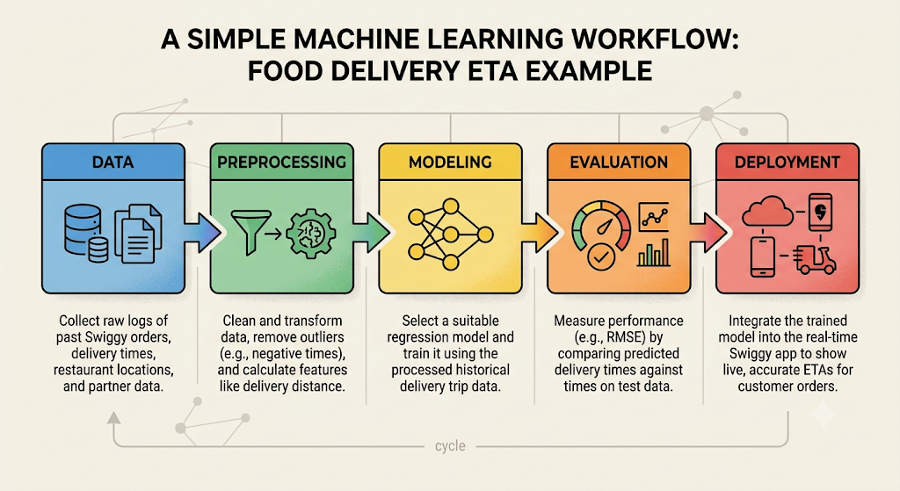

- Imagine you are building a spam filter for WhatsApp messages. Write a short paragraph explaining how traditional programming would approach this problem versus how machine learning would approach it. Focus on rules vs learning from data.

If you were to build a WhatsApp spam filter using traditional programming, you would have to manually code a strict set of explicit rules based on known patterns—for example, writing an if-else statement to block a message if it contains specific words like "WINNER", "lottery", or "click this link". The major flaw here is that as soon as spammers tweak their text to "W1NNER" or "l0ttery", your system fails, forcing you to constantly update the code by hand.
In contrast, a machine learning approach relies on learning from data rather than hardcoded rules. You would feed an ML algorithm thousands of examples of messages already labeled as "spam" or "not spam" (ham). Instead of relying on a human to spot the patterns, the model automatically discovers the subtle statistical relationships, keywords, and sending frequencies that indicate spam. If spammers adapt their language, you don't need to rewrite the program; you simply retrain the model with the new data, allowing the filter to evolve and catch sophisticated spam patterns automatically.

